1. Introduction

1.1 Purpose

To explore, design, implement and test a playable 2D multiplayer game using the .NET technology, the C# language, and the MonoGame libraries. Our project will be a turn based strategy game known as Chinese Checkers.

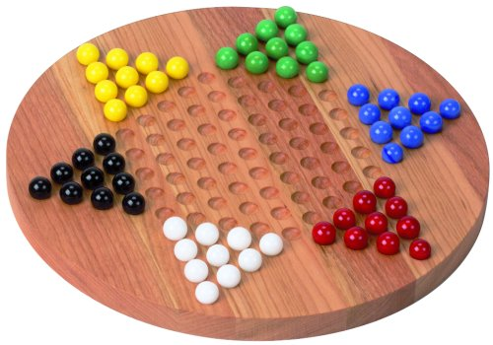

The goal of Chinese Checkers is to get all of you marbles from your starting position to the starting position of the opponent opposite from you. Pieces are able to move to any open space and may skip over other pieces if there is an open space behind it.

We chose this kind of project because we are both interested in designing and implementing our own 2D game that is playable over a local area network(LAN). We would both be able to create something we enjoy which would in turn inspire passion for the project.

1.2 Team contact information

Team: Stern-Halma

Chun-Yip Tang A00697550

E-mail: koolman987654321@hotmail.com

Justin Mclennan A00896174

E-mail: justin.mcle@gmail.com

1.3 Description and Scope

As mentioned above, the goal of our game is to fully transfer all your pieces to the starting position of your opponent opposite to you. Pieces are able to move one space at a time, unless you are able to skip over other marbles with an empty space behind them, players are able to chain these skips together if possible. This is a turn based game played off a hex grid board.

The game will have the following limitations:

* The game will be 2D
* The game will end when one player transfers all pieces to their final position
* The game will only be multiplayer
* The game will not have a leaderboard
* The game will not have any scoring
* The game will only be playable with even number of players (2,4,6)
* The game will only be playable over LAN
* The game will not have save/load states

2. Project Proposal

2.1 Existing Systems

While Chinese Checkers has been around since 1892 under the name "Stern-Halma", we wish to implement a newer version in which 2 or more players can over a network.

2.2 Proposed Solution

Players will have assigned turns based on RNG

Up to 6 people playing concurrently

Players can choose their piece’s colour from a set number of colours

Will use the .NET framework

Will be coded in C#

2.3 Alternative Solution

We were also thinking of maybe writing the game on the XNA framework. We have heard that by using the XNA framework, we can have it run faster than the .NET framework. We don’t know how this will impact our game, however we believe that learning the XNA framework will be an interesting experience

2.4 Technology

The technology used for this project will be C# and Microsoft Studios with the .NET framework, or C# and MonoGame with the XNA framework

2.5 Deliverables

* Design documents
* Project Proposal
* Unit Testing
* Coding
* Game Prototype
* Review and changes document
* Technical documents
* Finished game

3 Stages Plan

Stage 2

1. Plan visual style
2. Design hex grid system
3. Design classes
4. Design GUI
5. Design interfaces
6. Implement board
7. Implement piece movement
8. Implement turns
9. Design network interface

Stage 3

1. Revise classes
2. Revise interface
3. Code GUI
4. Implement network interface
5. Test gameplay
6. Implement more players

Stage 4

1. Test gameplay
2. Finalize GUI
3. Splash page
4. Main Menu
5. Fix bugs
6. Present

4 Users

Gamers

This game is created for Chinese checkers enthusiasts who want to play with others through a networked medium and for those who don’t wish to carry around a Chinese checkers board all the time.

5 Risks

|  |  |  |  |  |
| --- | --- | --- | --- | --- |
| Risk | Description of Resolution | Result / Decision | Ref to File | Status |
| Graphical Requirements | Have to move to XNA framework |  |  | Open |
| Time Constraints | refine the scope |  |  | Open |
|  |  |  |  |  |

6 Technical Issues

None so far.